The Power of Examples and Non-Examples

Been re-reading Englemann and Carnine's Theory of Instruction through a lens of what we know about learning from the last 50 years and realising the brilliance of it in terms of how it incorporates so much of how learning happens. It's not an easy read but for me the core concept in it is "faultless communication": the idea that teaching should be designed so precisely that misunderstanding is impossible.
One key idea is that students learn faster when they see what something is and what it isn’t. One of the most important aspect of curriculum planning + instructional design is effectively using examples and non-examples. By that I mean cases that are deliberately chosen to contrast with examples, differing only in the critical feature that defines the concept being taught. eg/ When teaching triangles, an example might be a three-sided shape, while a non-example could be a four-sided shape—not a random object like a cloud.
One of the mad things about examples/non-examples is that it's almost a unified theory of learning in the sense that so many theorists from a range of different traditions have advocated for it in one form or another. Socrates, Aristotle, Vygotsky, Bruner, Skinner, Ausubel, Sweller all basically say the same thing on this which is that learning is driven by clear distinctions—knowing what something is requires knowing what it isn’t. It's really about concept refinement but done in an incredibly detailed way.
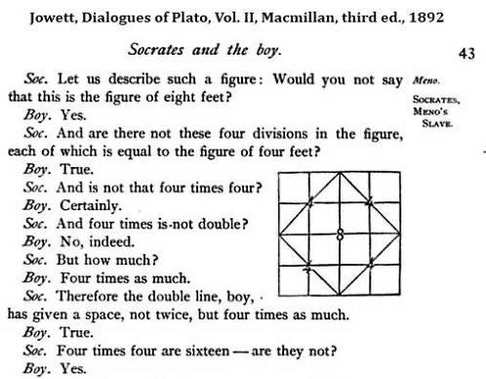
A key idea is that students need to see only relevant contrasts not arbitrary differences. In other words, when teaching a concept, the differences shown to a student should highlight the specific quality that defines that concept. A non-example should be almost identical to the example, differing only in the defining feature otherwise, students might focus on the wrong thing. Engelmann and Carnine developed five principles to do this:
1. The Wording Principle: To keep instruction clear, teachers should use consistent or nearly identical wording across examples. This minimises distractions and helps students focus on key details. Here, one pair maintains consistent wording, while the other introduces unnecessary variation, causing confusion.
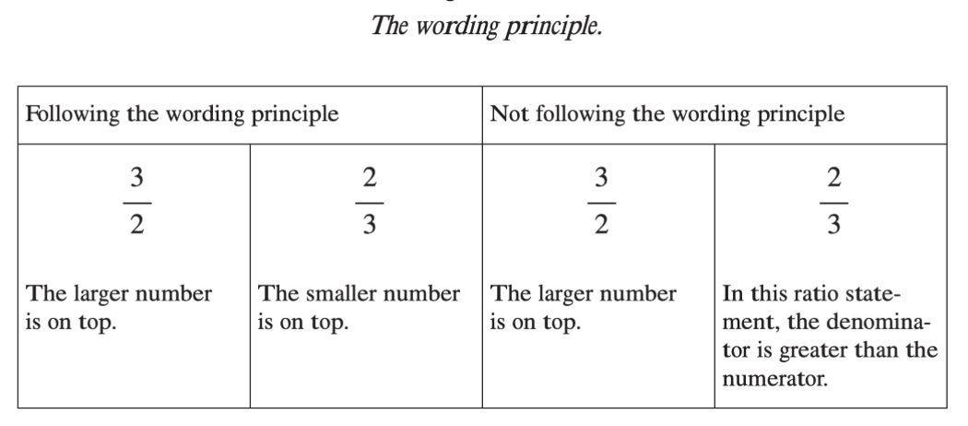
2. The setup principle: When introducing a new concept, examples and non-examples should be as similar as possible, differing only in the critical feature. If unnecessary differences exist, students may misinterpret the rule. Figure 2.2 demonstrates this: in the incorrect example, multiple differences create ambiguity—students might mistakenly associate the concept with shape, color, or position. Without careful control of contrasts, learning becomes guesswork rather than clarity. Direct Instruction prioritises precision to eliminate confusion.
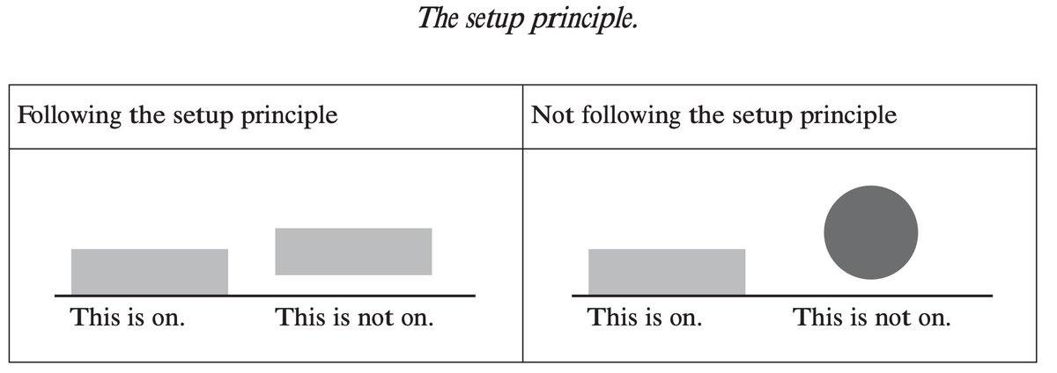
3. The Difference Principle. Positive and negative examples are most effective when they differ only slightly, but for this distinction to be clear, they must be presented consecutively. In set A, two examples are shown with minimal differences in orientation, making the contrast easy to grasp. However, in set B, the same examples appear but are separated by other items. Without direct comparison, the key difference is less obvious, and the learner may fail to recognize the defining feature. Juxtaposition ensures that critical distinctions are immediately noticeable, reinforcing accurate concept formation.
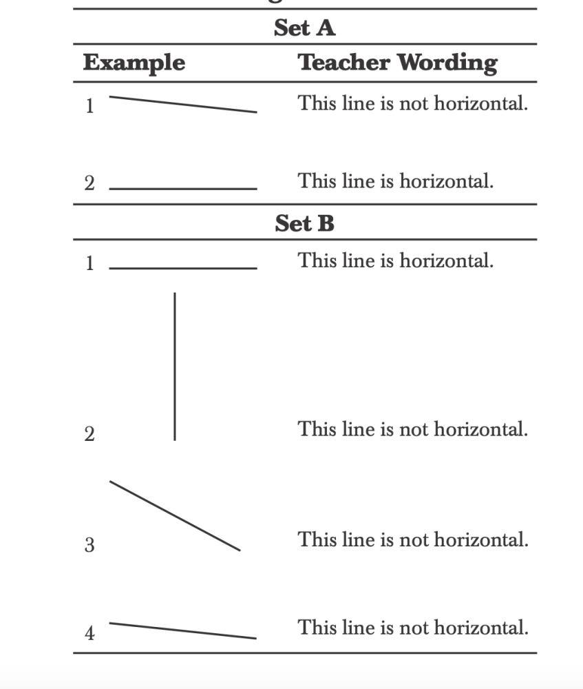
4. The sameness principle. To emphasize sameness, examples should be highly different yet share the same label. Here, various instances of "under" are shown—some erasers close to the table, others farther away, some centered, others near the edges. Despite these differences, the label remains the same, reinforcing that position changes do not alter the meaning of "under." The examples follow the wording principle (consistent phrasing), setup principle (same objects), and sameness principle (varying examples with the same label). By juxtaposing diverse cases, learners see that observed differences are irrelevant to the concept being taught.
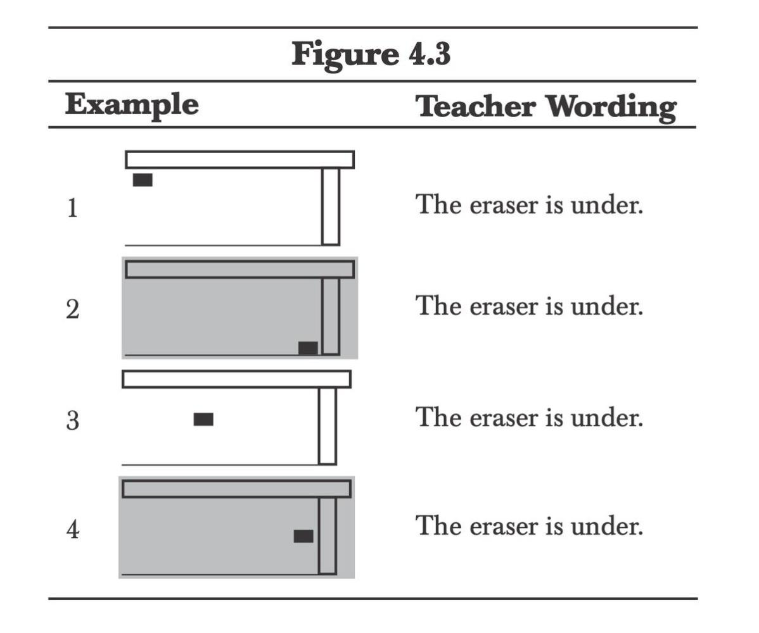
5. The testing principle.
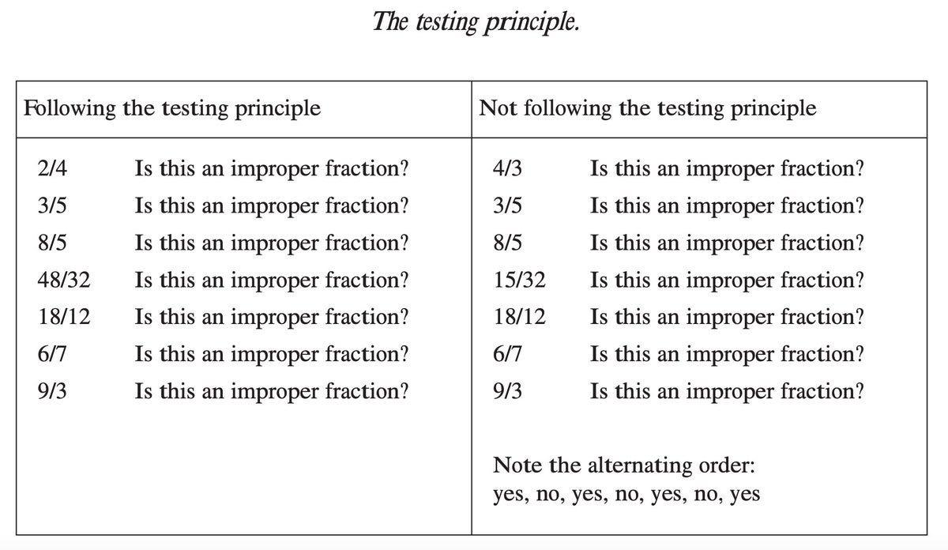
Putting it all together:
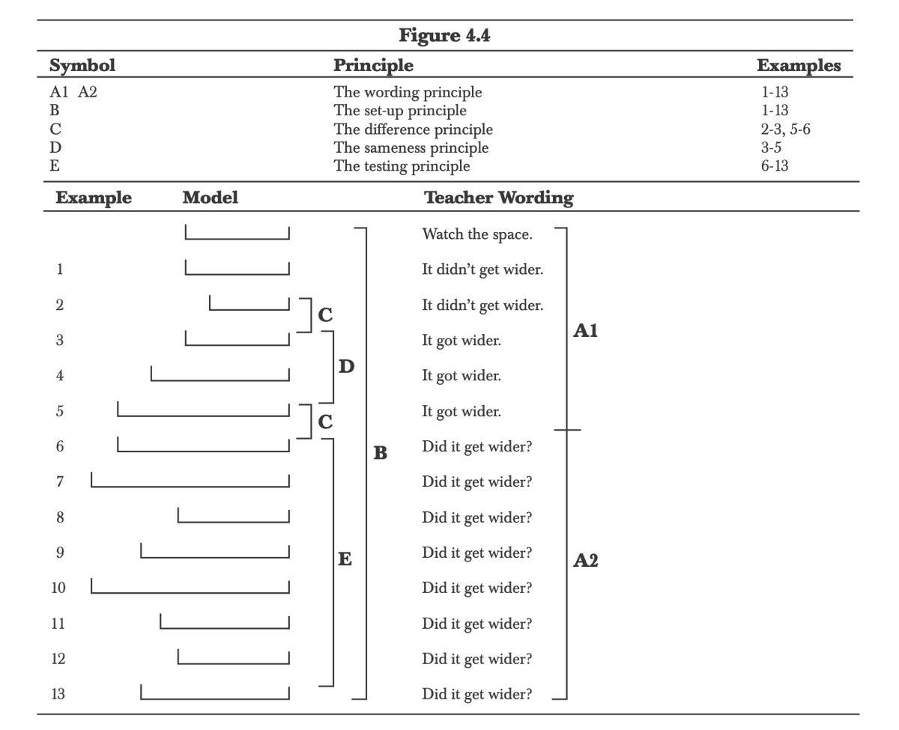
There's no doubt in my mind that DI is perhaps the most misunderstood theory of learning. I totally get that scripted lessons/choral response are not appropriate for every teacher but my god the brilliance of the instructional design and sequencing from the 1982 book should be studied by every teacher as Cathy Watkins points out:
